# **Name: Abdurrahman Qureshi**

# **Roll No: 210451**

Practical No: 6

**1) Write a Program to demonstrate pass by value.**

**CODE:**

<?php  
  
function passByValue($x,$y){  
 return $x + $y;  
}  
  
echo passByValue(10,20);

**OUTPUT:**

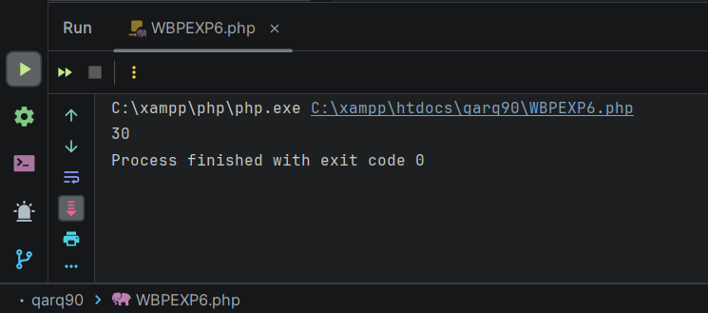

**2) Write a Program to demonstrate pas by refrence**

**CODE:**

<?php  
  
$z = 10;  
function passByRef(&$x)  
{  
 return $x++;  
}  
  
echo $z;  
passByRef($z);  
echo "\n" . $z;

**OUTPUT:**

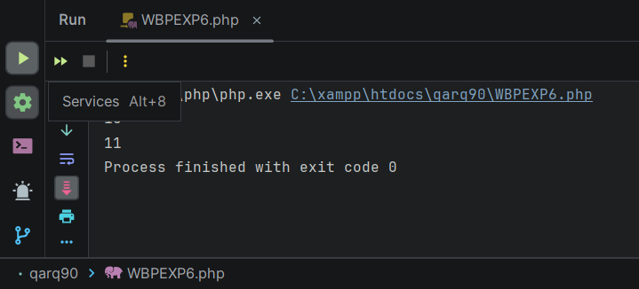

**3) Write a Program to demonstrate default arguments**

**CODE:**

<?php  
  
function defaultArguments($a, $b = "Money")  
{  
 echo $a . $b;  
}  
  
defaultArguments("Arthur, we need ");

**OUTPUT:**

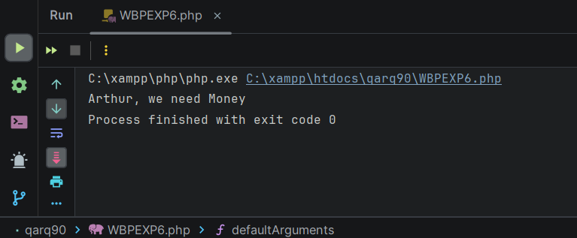

**4) Write a Program to demonstrate variable functions**

**CODE:**

<?php  
  
function variableFuntion($a, $b)  
{  
 echo $a . $b;  
}  
  
$x = "variableFuntion";  
$x("Arthur, we need ", "money");

**OUTPUT:**

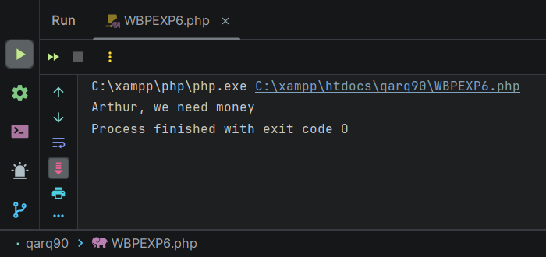

**5) Write a Program to convert the String to Uppercase, Lowercase, capitalize the first character of a string.**

**CODE:**

<?php  
$test_string = "Death is an old friend";  
echo "Original string: " . $test_string . " \n";  
$to_lower = strtolower($test_string);  
echo "String converted to lowercase: " . $to_lower . " \n";  
$to_upper = strtoupper($to_lower);  
echo "String converted to UPPERCASE: " . $to_upper . " \n";  
$first_character_capitalized = ucwords($test_string);  
echo "String where the first word has been capitalized: " . $first_character_capitalized;  
?>

**OUTPUT:**

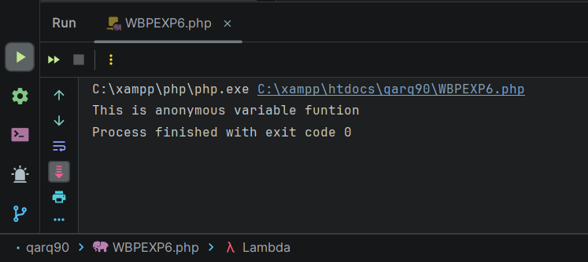

**6) Write a Program to demonstrate anonymous functions in an array**

**CODE:**

<?php  
  
$functionAnonymous = [  
 function () {  
 echo "\nIndex 0";  
 },  
 function () {  
 echo "\nIndex 1";  
 },  
 function () {  
 echo "\nIndex 2";  
 },  
];  
  
$x = $functionAnonymous[0];  
$y = $functionAnonymous[1];  
$z = $functionAnonymous[2];  
  
$x();  
$y();  
$z();

**OUTPUT:**

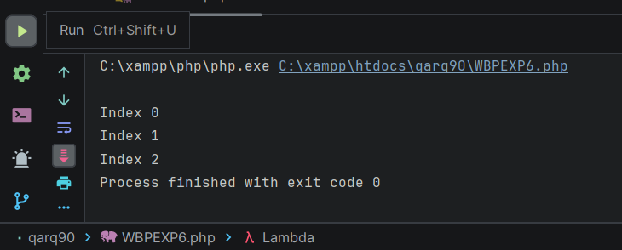

**7) Write a Program to demonstrate callback anonymous function**

**CODE:**

<?php  
  
$indexed_array = array("Ripper", "Annihilator", "Purifier", "Scythe", "Sparrow");  
  
array_walk($indexed_array, function ($n) {  
 echo $n . "\n";  
});

**OUTPUT:**

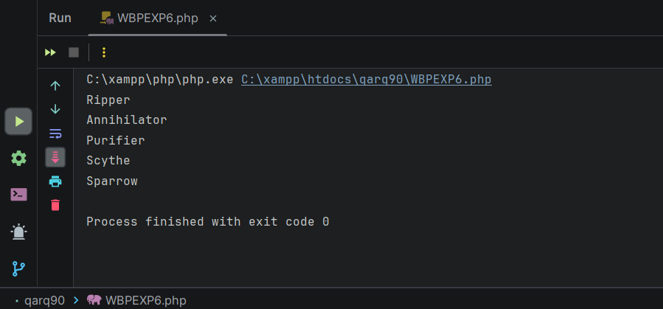

**8) Write a Program to demonstrate closure in anonymous functions**

**CODE:**

<?php  
  
$a = 10;  
$b = 20;  
$c = 30;  
  
$functionAnonymous = [  
 function () use ($a) {  
 echo "\nIndex 0" . $a;  
 },  
 function () use ($b) {  
 echo "\nIndex 1" . $b;  
 },  
 function () use ($c) {  
 echo "\nIndex 2" . $c;  
 },  
];  
  
$x = $functionAnonymous[0];  
$y = $functionAnonymous[1];  
$z = $functionAnonymous[2];  
  
$x();  
$y();  
$z();

**OUTPUT:**

